Dear Montrose Primary School Families,
In 2024, we are delighted to advise that we will once again partner with Ross Office Supplies to coordinate our Student Pack ordering and collection of money for Curriculum Contributions and Other Contributions.
This service will again offer the flexibility for parents to order less, or more stationery if required. There is also the option for home delivery or pick up from the school.
Please find the details outlining dates and the process for ordering attached to this letter.
Payment is made through the Ross Office Supplies site – the flyer with full instructions is attached to this letter. Parents/guardians are welcome to purchase identical items themselves and pay the Curriculum Contributions and Other Contributions directly to the school office.
Please note that 100% of monies collected for Curriculum Contributions and Other Contributions goes to the school.
Montrose Primary School is looking forward to a great year of teaching and learning and would like to advise you of Montrose Primary School’s voluntary financial contributions for 2024.
Schools provide students with free instruction to fulfil the standard Victorian curriculum and we want to assure you that all contributions are voluntary. Nevertheless, the ongoing support of our families ensures that our school can offer the best possible education and support for our students. We want to thank you for all your support, whether that’s through fundraising or volunteering your time. This has made a huge difference to our school and the programs we can offer.
Within our school this support has allowed us to offer a wide variety of curriculum offerings, wellbeing programs, enrichment activities, enhanced science, technology and digital learning opportunities, classroom and general libraries, sporting equipment and facilities for children such as new and improved play areas.
For further information on the Department’s Parent Payments Policy please see a one-page overview attached.
If you have any questions, we are happy to help at the office.
Yours sincerely,
Kylie Fisher Bree Kuffer
Principal School Council President

Curriculum Contributions – Voluntary financial contributions for curriculum items and activities which the school deems necessary for students to learn the Curriculum. | Amount
Year 5 & 6 classroom consumables, materials & equipment  - Art – Various specialised paper for-drawing, painting, creating collage. Dyes, inks, water colours, acrylic paint, polystyrene balls. Clay underglaze and glaze, oil pastels, chalk pastels, textas, pencils, various glues, collage items for example-feathers, eyes, wool tops, felt, chenille stems, wire, popsticks, cardboard shapes, beads, threads, glitter, canvas, various wires, foil, foam printing sheets, Colour Slicks, Posca pens, Paper Magiclay, plaster fabric, felting wool, acetate sheets, raffia, mosaic tiles, texture paint and a canvas. ($70)  - English, Maths, LOTE, Drama & Music classroom materials – includes printing of learning materials ($25)  - STEM – Science, Technology, Engineering & Mathematics Activities ($25)  - Student Diary ($10)  - Food Technology - Students will be involved in a small number of cooking sessions throughout the year linked to our Grade 3 & 4 Kitchen Garden program. The cost assists with the purchase of ingredients and school grown produce for food preparation and cooking ($20) | $150
Year 5 & 6 Digital Technology – The technology contribution assists with the cost of technology in the school - hardware, software, digital learning devices (ie iPads, netbooks and computers). This contribution also assists with the upkeep and upgrading of digital learning devices, subscriptions to providers etc. | $20.00
Other Contributions – Voluntary financial contributions for non-curriculum items and activities that relate to the school’s functions and objectives. | Suggested Amount  (Per Family)
School grounds maintenance and improvements (in lieu of working bees) | $20.00
Tax deductible contributions – ANY AMOUNT would be greatly appreciated thank you
Building fund. A tax-deductible contribution to support renovations, upgrades, and maintenance of school infrastructure. | $
Library fund. A tax-deductible contribution to support book purchases and other equipment that sustain the library as a valuable resource. | $
Total Amount | $

Educational items for students to own
For a list of items that the school recommends you purchase from Ross Office Supplies, for your child to individually own and use, please follow the information on the attached sheet – “2024 BOOKLISTS”.

Financial Support for Families
Montrose Primary School understands that some families may experience financial difficulty and offers a range of support options, including:
- the Camps, Sports and Excursions Fund
- State School’s Relief
- Financial assistance from our “Financial Hardship Fund” for families experiencing hardship.
For a confidential discussion about accessing these services, or if you would like to discuss alternative payment arrangements, contact: Sue or Jodie.
Ph: 03 97282203 | Email: montrose.ps@education.vic.gov.au
Total
Category
Curriculum Contributions | $170.00
Other Contributions | $20.00 plus building/library fund donation as listed.
Extra-Curricular Items and Activities | Nil

Payment methods

Credit card, BPay, Direct Deposit or cash.

Refunds

Parent requests for refunds are subject to the discretion of the school and made on a case-by-case basis. Refunds will be provided at the start of 2024, for Curriculum Contributions and Other Contributions if your child does not start at Montrose Primary School. Unfortunately, refunds cannot be given for donations to the Building or Library Fund.
The Refund Policy is available for viewing on the school’s web site.

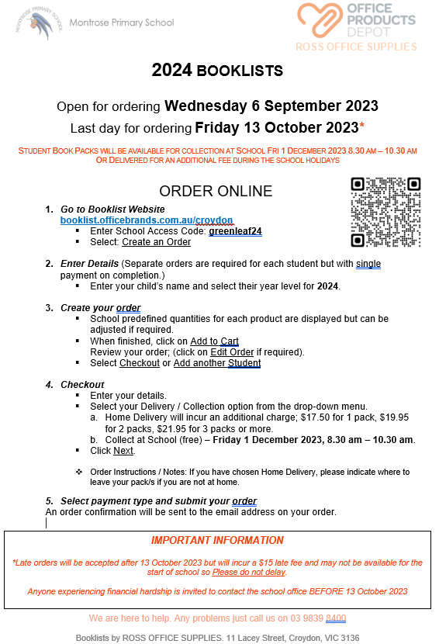

parent PAYMENTS policy

ONE PAGE OVERVIEW
 | FREE INSTRUCTION  - Schools provide students with free instruction and ensure students have free access to all items, activities and services that are used by the school to fulfil the standard curriculum requirements in Victorian Curriculum F-10, VCE and VCAL.  - Schools may invite parents to make a financial contribution to support the school.

 | PARENT PAYMENT REQUESTS  Schools can request contributions from parents under three categories:  - Schools may also invite parents to supply or purchase educational items to use and own (e.g. textbooks, stationery, digital devices).
  Curriculum Contributions  Voluntary financial contributions for curriculum items and activities which the school deems necessary for students to learn the Curriculum. | Other  Contributions  Voluntary financial contributions for non-curriculum items and activities that relate to the school’s functions and objectives. | Extra-Curricular Items and Activities  Items and activities that enhance or broaden the schooling experience of students and are above and beyond what the school provides for free to deliver the Curriculum. These are provided on a user-pays basis.

 | FINANCIAL HELP FOR FAMILIES  - Schools put in place financial hardship arrangements to support families who cannot pay for items or activities so that their child doesn’t miss out.  - Schools have a nominated parent payment contact person(s) that parents can have a confidential discussion with regarding financial hardship arrangements.

 | SCHOOL PROCESSES  - Schools must obtain school council approval for their parent payment arrangements and publish all requests and communications for each year level on their school website for transparency.

